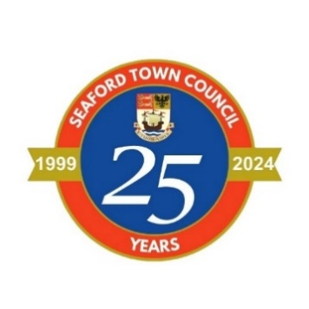

IMMEDIATE RELEASE
Date 01/08/2024
Contact: Lucy Clark, Finance Manager
lucy.clark@seafordtowncouncil.gov.uk
01323 894870

Seaford Town Council Supports Local Groups through its 2024-2025
Grant Scheme
The Town Council has granted £22,718 as part of its annual grants scheme to benefit the town and its residents.
SEAFORD, 1st August 2024 – Seaford Town Council is pleased to announce that following the 2024-2025 grants process, nineteen local organisations have been awarded financial grants totalling £22,718. All grants will directly benefit the residents of Seaford and the town itself.
The Town Council would like to thank these organisations for their continued hard work and contribution to the town and is delighted to be able to assist and support these organisations where possible.
The following grants were awarded:
Air Ambulance Charity Kent Surrey Sussex was awarded £500 towards the ongoing operating costs of HEMS (Helicopters, Rapid Response Vehicles, Medical Equipment, Fuel & Highly Trained Crews).
Seaford Community Garden was awarded £300 towards working in partnership with Seaford Medical Practice and to enable the purchase of 15 yoga mats, a storage unit, a smart speaker, 15 pots, seeds, compost & refreshments for patients.
Seahaven Poets was awarded £125 towards the costs for LitFest 2025.
The Base was awarded £350 towards purchasing a new Bass Amp.
Bishopstone United Charities was awarded £2,000 to replace two rear windows, one for each dwelling in Eadric House as currently in a state of disrepair.
Care for the Carers was awarded £603 towards the delivery of four Young Carers Clubs over the year at the Mecread Youth Centre.

Cuckmere Valley Canoe Club was awarded £2,586 towards replacing a number of Junior Boats which are now 10 years old along with buoyancy aids, helmets and paddles to enable to continue providing junior kayaking sessions.
Culture Connect Project CIC was awarded £1,050 to cover costs associated with hosting free of charge weekend events at The Mercread Centre, offering local families an enriching experience that celebrates diversity through creative expression.
Family Support Work (FSW) was awarded £1,000 towards funding the costs for home-visits offering practical & emotional support to vulnerable families living in Seaford over twelve months.
GIA (Gardening in Action) CIC was awarded £1,000 towards renovating, enhance & maintain the platform planters at Seaford Station.
Newhaven & Seaford Sea Cadet Corps was awarded £1,050 towards a shed and base to store charity equipment.
Seaford Bonfire Society was awarded £2,000 towards the cost of medical emergency professionals along with the costs towards the event security.
Seaford Community Events Committee was awarded £900 towards the cost of security at Motorfest.
Seaford District Guides was awarded £1,600 towards the cost of four tents for the Brownies and Guides camping experiences.
Seaford Dramatic Society (Seaford Little Theatre) was awarded £1,750 towards essential roof repairs.
SEDS Connective was awarded £504 towards the course leader costs for wellbeing courses within Seaford.
St James’ Trust (Seaford) was awarded £2,400 to help fund the weekly Minibus Hire for the Tuesday Lunch Club.
St Wilfrid’s Hospice was awarded £1,000 towards supporting people who wish to remain at home when they are diagnosed with a terminal illness.
Teddy Treats Children’s Charity was awarded £2,000 towards the Christmas Panto and two activities.
The Mayor of Seaford, Cllr Sally Markwell said, “Thanks to everyone who applied for the Seaford Town Council grants, whether successful or not, you are all working hard and showing how much you care about the Seaford community.”
The next grants process will commence in April 2025 when application forms will be available to download from the Town Council’s website. If you would like further information then please email Lucy Clark, Finance Manager, at lucy.clark@seafordtowncouncil.gov.uk

###

